**SC531 – Lecture #08**

**RANDOM VARIABLES (continued)**

**Examples from Ref. #02**

(1) RV X takes on values 1, 2, 3, 4 such that:

2*Prob(X=1) = 3*Prob(X=2) = Prob(X=3) = 5*Prob(X=4).

Find the probability distribution and the cumulative distribution function (cdf) of X.

Let Prob(X=3) be K. Then the four probabilities are: K/2, K/3, K and K/5 respectively.

Since the four probabilities must add up to 1, with LCM(2,3,5) = 30, we get:

(15 + 10 + 30 + 6)*K/30 = 1, which gives K = 30/61.

See chart (random-variables-02).

(2) Show that function p(x) defined below is a valid pdf, and find its cdf.

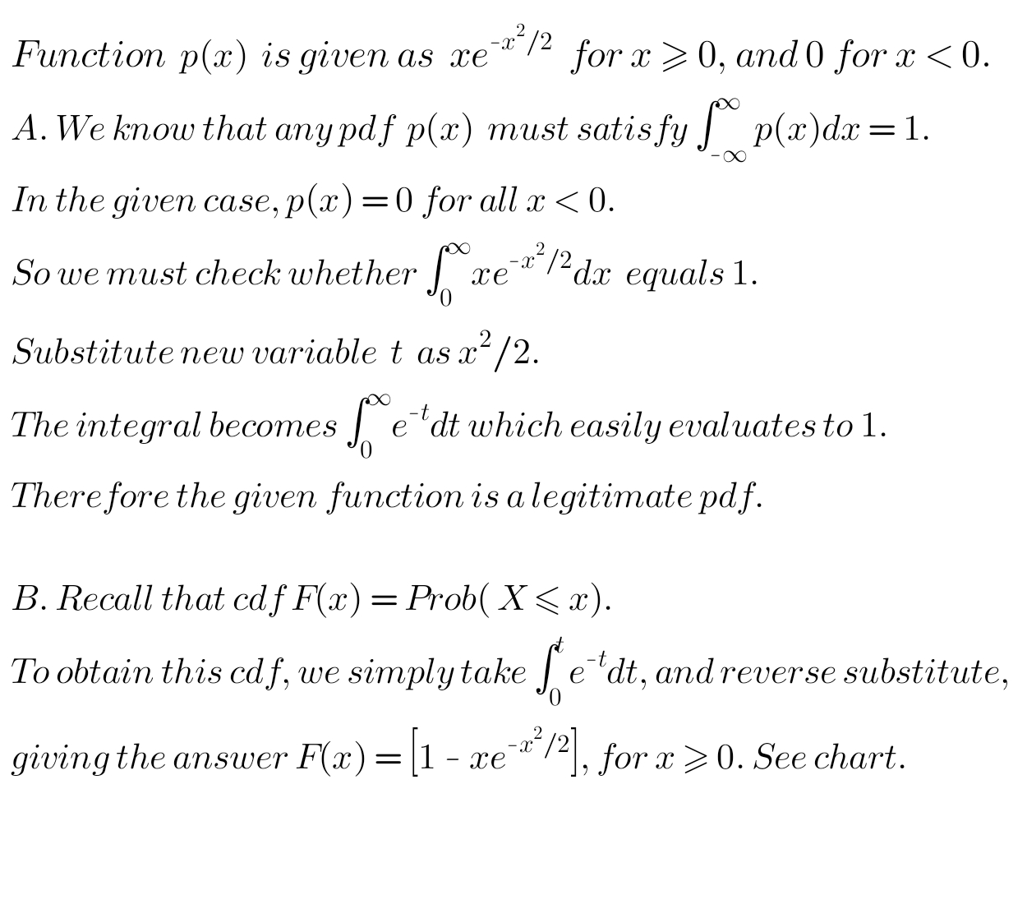



(3) A continuous RV X follows the pdf N(0,2). Find Prob(1 < X < 2).

See chart (normal-distribution).

**MEAN – OR EXPECTED VALUE – OF A RANDOM VARIABLE**

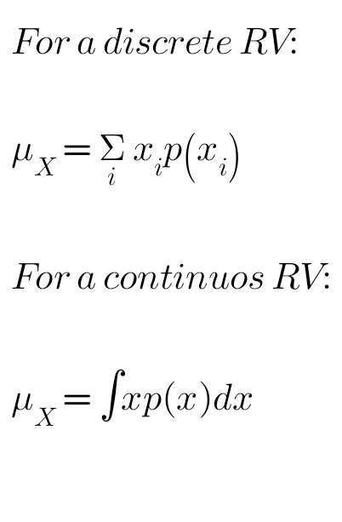An important property of a RV, defined as follows:



The range of summation and integration, as the case may be, equals the range of values that the RV can take.

**Simple examples:**

(1) X is the result of rolling a fair die. mX = 3.5 🡪 Why?

(2) X is the result of rolling a pair of fair dice. mX = 7 🡪 Why?

Recall the probability distribution function, seen before.

(3) X is the weight of a student of DAIICT, uniformly distributed continuous variable between 50 kg and 60 kg. mX = 55 kg 🡪 Why?

[BTW, can student weight truly be taken as a real-valued variable?]

(4) Consider the RV X defined by the normal distribution N(10,2).

mX = 10 🡪 Why?

Note that all the above probability functions are **symmetric** about their respective means.

(5) Now we see a probability function which is NOT symmetric about its mean. Let ‘grade' be a random variable which we denote by X, which has integer values from 4 to 10, with probabilities as shown.

|  |  |  |  |  |  |  |  |
| --- | --- | --- | --- | --- | --- | --- | --- |
| x | 4 | 5 | 6 | 7 | 8 | 9 | 10 |
| P(x) | 0.05 | 0.1 | 0.1 | 0.2 | 0.3 | 0.2 | 0.05 |
| x*P(x) | 0.2 | 0.5 | 0.6 | 1.4 | 2.4 | 1.8 | 0.5 |

The summation of x*P(x) equals 7.4, which is the mean of this random variable.

(6) What would be the mean of the above variable if all the grade values from 4 to 10 were equi-probable?

Verify answer 🡪 7.

Note: (a) If all values of a discrete RV are equi-probable, then the distribution is necessarily symmetric about its mean.

(b) The mean itself may or may not be a permissible value of the RV. See examples (1), (2) and (5) above.

(7) For the binomial distribution, nCi piq(n-i), it can be shown that the mean is given by m = n*p. Suppose we toss a biased coin with P(head) = 0.6 a hundred times. RV X is the number of heads seen. Then mX = 60.

**POISSON DISTRIBUTION**

Defines a **discrete random variable** related to a discrete process occurring at a **uniform rate** – but it is not a deterministic process!!!

Examples: The number of requests arriving at a web server, the number of packets arriving at a router, the number of cars crossing a bridge, the number of customers arriving at a bank ... *et cetera*. **Per unit time**.



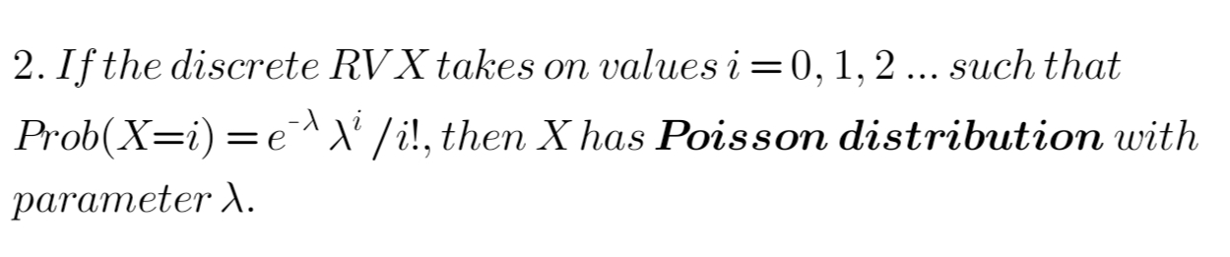The mean value m of a Poisson distributed RV is simply l.

A Poisson process is said to be **memoryless**.

Whatever this distribution says for time interval (slot) 1, applies equally at time intervals 2, 3, 4 ....

In other words, the occurrence or non-occurrence of an event in one time interval does not affect the probabilities of occurrence in other time intervals. The parameter l is also known as the *rate*.

See chart (poisson-distribution).

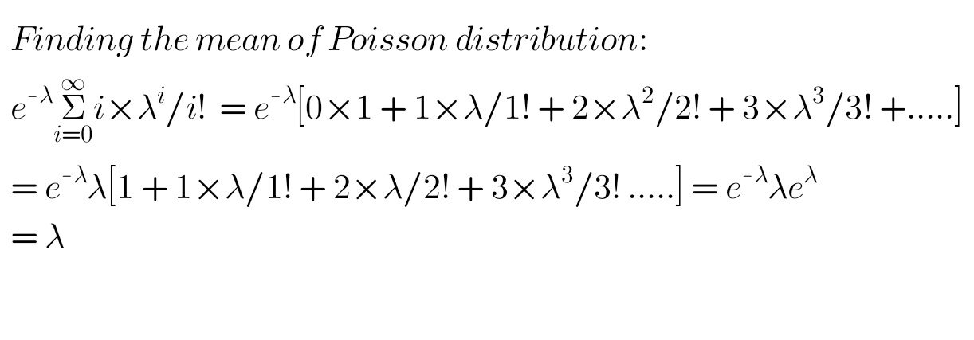

Please read this power as 2.



**GEOMETRIC DISTRIBUTION**

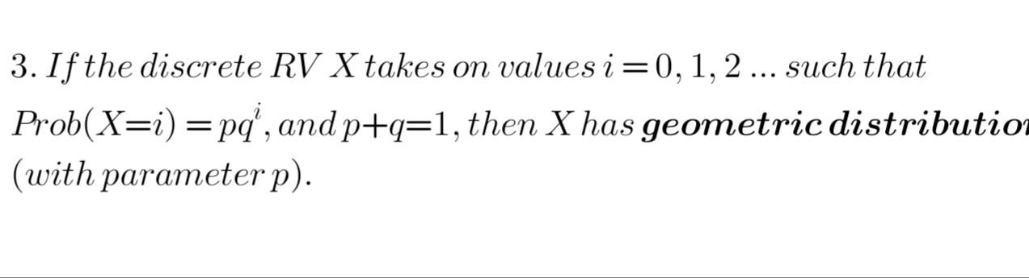

Concept: Here the discrete RV stands for the number of repeated failures before a success occurs.



Mean of this distribution can be shown to be *q/p*. The method followed is basically similar to that seen above.

Example (1): We roll a fair die repeatedly. What is the mean number of rolls required **before** we see 6?

*q* = 5/6, *p* = 1/6.

Answer: *q/p =* 5.

Example (2): Team A and B are playing a series of games. In any given game, team A has 0.2 probability of winning. How many games is team B **expected** to win before team A wins for the first time?

q = 0.8, p = 0.2.

Answer: 4.

Example (3): In a forest cave, a spider has probability 1/8 of making it to the top of a cave in one attempt. What is the expected number of failed attempts it has to make before the successful one?

Answer: 7.

***

NOTE: The mean of a RV is often also called its **expected value**, and denoted as Exp[X], if X is the RV. So Exp[X] = mX.

DISCUSSION: It should be clear to all that the values of a RV must necessarily be spread on both sides of its mean. How can we quantify the “spread" of a random variable around its mean?